Bolt Lite Container Instructions

1. **docker pull boltiq/boltlite:latest**
2. docker run --name boltlite -v **/home/bolt/code**:/src -p 5901:5901 boltiq/boltlite:latest
3. edit the location **"/home/bolt/code/"** to a known local location or create the provided directory path
4. VNC into the container using your docker IP and port 5901
5. Goto your local volume location /home/bolt/code
6. Git Clone <https://github.com/boltio/boltlite.git> ( you can also download ZIP and unzip contents your local volume location.

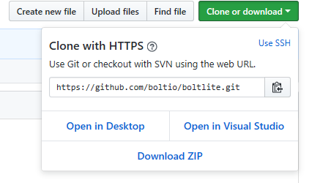

* 1. Verify you have a bolt folder and a JAR file like this:

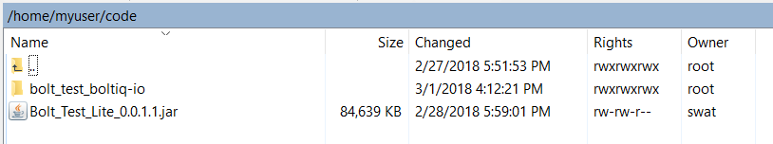

1. Open VNC and launch Intellij ( The default VNC password is password)
2. The Bolt project will be loaded and indexed.
3. Open the Boltiq spec and run it to verify working installation

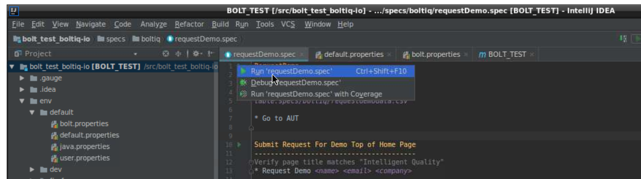

1. Chrome Browser should open and run the SPEC

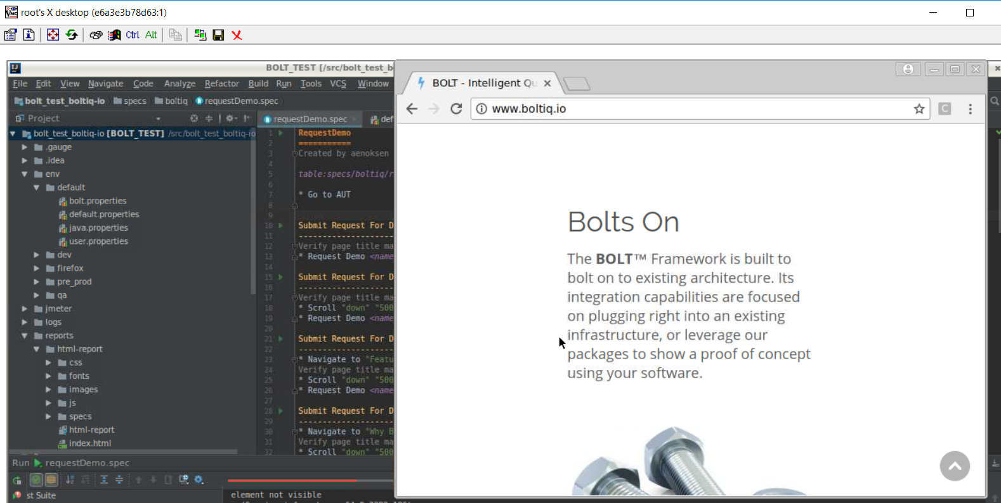

1. Your Bolt environment is set up and ready for you to use !!